**Task 3 , 15/1/25**

1. Query the list of *CITY* names from **STATION** that *do not start* with vowels. Your result cannot contain duplicates.

**Input Format**

The **STATION** table is described as follows:

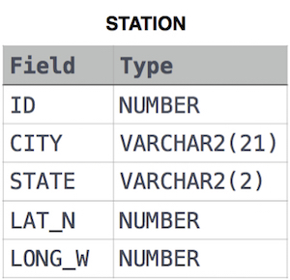

where LAT_N is the northern latitude and LONG_W is the western longitude.

**Solution**: SELECT distinct CITY FROM STATION

WHERE lower(SUBSTRING(CITY,1,1)) NOT IN ('a','e','i','o','u')

1. Query the list of *CITY* names from **STATION** that *do not end* with vowels. Your result cannot contain duplicates.

**Input Format**

The **STATION** table is described as follows:



where LAT_N is the northern latitude and LONG_W is the western longitude.

**Solution** : SELECT distinct CITY FROM STATION

WHERE lower(SUBSTRING(CITY,-1,1)) NOT IN ('a','e','i','o','u')

1. Query the list of *CITY* names from **STATION** that either do not start with vowels or do not end with vowels. Your result cannot contain duplicates.

**Input Format**

The **STATION** table is described as follows:



**Solution**: SELECT distinct CITY FROM STATION

WHERE lower(SUBSTRING(CITY,1,1)) NOT IN ('a','e','i','o','u')

or lower(SUBSTRING(CITY,-1,1)) NOT IN ('a','e','i','o','u')

1. Query the list of *CITY* names from **STATION** that *do not start* with vowels and *do not end* with vowels. Your result cannot contain duplicates.

**Input Format**

The **STATION** table is described as follows:



where LAT_N is the northern latitude and LONG_W is the western longitude.

**Solution:**  SELECT distinct CITY FROM STATION

WHERE lower(SUBSTRING(CITY,1,1)) NOT IN ('a','e','i','o','u')

And lower(SUBSTRING(CITY,-1,1)) NOT IN ('a','e','i','o','u')